Extended Abstract Title of Presentation

Name SURNAME^{1,}*, Name SURNAME² and Name SURNAME^{1,3}

*Corresponding author e-mail: only_one_author@organisation.com

¹Department, Organization, Address, City, Country,
²Department, Organization, Address, City, Country,
³Department, Organization, Address, City, Country.

Abstract
The simplest way to use this template is to replace the text in this file with your own words using the styles provided as far as possible.
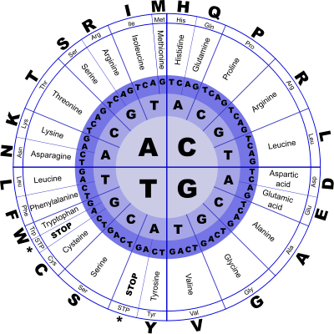
The length of Extended Abstract is in the range between 350 and 500 words (excluding Keywords, References and Acknowledgements). Abstract cannot be longer than one page in total. References and Acknowledgment are not obligatory. If necessary, the Abstract can include a picture, graphic or table. For the figure, use the Square option, not In Line with Text. For the table, use the Around option.
Abstracts should be submitted online by May 25th, 2023. Authors will be notified of abstract acceptance and eligibility for reimbursement by May 30th, 2023.
Researchers are invited to present their research in accordance with the goals and objectives of WG1, as well as to highlight areas of their research in which they could collaborate with other members of DINALIFE Action, regardless of WG affiliation. One of the expected outcomes of the WG1 Meeting is the preliminary mapping of research groups and areas, as well as the setting of the initial strategic research agenda through the identification of priority areas and approaches for further research. To facilitate this process, DYNALIFE members are expected to prepare 10-20 minutes presentation describing their past, current and future work activities related to WG1 objectives and tasks, and inspire other WG members looking for potential collaboration.
Referencing according to the Scientific Style and Format Citation Quick Guide: https://www.scientificstyleandformat.org/Tools/SSF-Citation-Quick-Guide.html. For the in-text reference, use parentheses and list author(s) by surname followed by year of publication: (Author(s) Year). References should be listed in alphabetical order in the reference section.

Keywords
keyword1, keyword2, keyword3, keyword4. (max. 6)

Reference (optional)
Author(s). Year. Article title. Journal title. Volume(issue):location.
Author(s). Year. Title. Edition. Place of publication: publisher.

Acknowledgment (optional)
This work was funded by…

